1114l

Management Studies Tripos

CORE MODULE
COURSEWORK

MS3

Economics of Firms and Markets

Course Leader: Dr. Frederic Schneider

Hand-in date:
03/05/21

999
(1000)

I confirm that this piece of work is my own unaided effort and conforms with the Judge Business School guidelines on Plagiarism
(Do NOT sign)

Introduction
Collusion occurs when rival firms use anti-competitive practices to form a “cartel” in pursuit of higher profits. These firms colluded to create a buying cartel. This means, through colluding, they exerted monopsony power over sellers. This essay will explain why this occurred, and its welfare impacts on various agents. These analyses, and relevant literature, will inform policy recommendations.
Cartel Formation and Survival
Cartel stability is the strength of firms’ commitment to the collusive practice. According to Feinberg (2016), its determinants are the profit gained from colluding, the difficulty of monitoring members, and the probability of government prosecution.
This collusion was motivated by the potential to raise profits. “No poaching” policies reduced competition for labour, thus creating monopsony power. Figure 1 shows that the monopsonist profit-maximises by hiring Q_{M} units of labour, where MC_{L} equals MRP. In perfect competition, wages equal MRP, at W*. However, monopsony power means the cartel need only pay W₃, the AC_{L} at quantity Q_{M}. Hence labour is under-consumed and under-priced relative to the competitive equilibrium. Area (A+B) shows the lower costs (thus increased profits) the cartel achieves. Comparing Figures 1 and 2 shows why collusion was particularly attractive for these firms. Price elasticity of labour supply is likely low in the high-tech market because software engineers have accumulated much human capital. Labour demand is likely price inelastic because it is difficult to substitute other factors into this role. These low price elasticities increase the size of Area (A+B), the cost-savings from collusion.
Due to the market’s concentration, the cartel required only a small number of oligopolists to create monopsony power. This likely facilitated communication within the group, which enables to higher levels of co-operation in social dilemma situations, where rational self-interest leads to Pareto-dominated outcomes. Bichhieri and Lev-On (2007) find that communication allows people to develop mutual beliefs about behaviour, and agreement to co-operate increases the guilt cost of defecting (Miettinen and Suetens, 2008). Further, the cartel may have been sustained by the ease of monitoring members. The high level of transparency in the market would make it easy to identify dissenters. Monopoly cartels are vulnerable if firms can discreetly exceed their sales quota, thus increase their profits. In this situation it is difficult to dissent discreetly; if an Apple employee is hired by Google, the employee will hand in their notice and likely discuss the situation with their manager. The combination of these factors would decrease the payoff of leaving the cartel, thus increasing its stability.
Welfare Consequences
The cartel’s welfare effects have already been touched upon. Figure 1 shows that labour is under-unemployed relative to the competitive equilibrium. Further, employed labour is paid less than its marginal revenue product, being exploited by the value of (W₂-W₃). Lower real incomes in monopsony markets are empirically supported (Kleiner and Park, 2010), and contribute to lower worker mobility (Manning, 2020) and standards of living.
The welfare of the firms in the cartel increases due to their monopsony power. Figure 4 shows how the reduced wages of labour translate into lower average and marginal costs for the cartel. This increases the cartel’s abnormal profits from (A+B) to (B+C+D), increasing its welfare by [(C+D) – A].
The welfare effect on customers is ambiguous, depending upon whether the cartel passes on its cost-savings to customers. Consider the NHS, which uses its monopsony power to ultimately deliver lower prices. Here, monopsony power is welfare-enhancing for customers. However, customers are unlikely to benefit from the collusion of these tech firms, given most are not competing on price. For example, Apple is unlikely to reduce the price of its new iPhone, which will have a price inelastic demand curve. Crucially, by under-employing labour, the cartel creates a deadweight welfare loss (DWL) for society. When the cartel exerts its monopsony power to reduce labour quantity and price, some producer surplus is converted into consumer surplus (Area A). However, Figure 3 shows that community surplus falls by Area C, the DWL, meaning the gains to trade are not fully realised.
Policy Recommendations
This DWL justifies policy intervention to tackle the monopsony power. Enacting legislation to strengthen trade unions can create a bilateral monopoly by allowing employees to act as a single seller. Figure 5 shows their increased market power being leveraged to obtain wage W_{T}, without a fall in employment. Whilst this policy protects employees, it fails to recapture the DWL of Area C. A more effective policy could raise the minimum wage. In a monopsony market only, raising the floor price on labour to W* (Figure 3) would achieve the competitive equilibrium (W*, Q*), thereby avoiding the DWL. However, minimum wage legislation would be unhelpful in this scenario; the aforementioned price elasticity of demand and supply in the high-tech labour market will mean W* and even W₃ are several multiples of the national minimum wage.
Nevertheless, the DWL need not be accepted because this monopsony power is artificial, the result of collusion rather than market structure. Pham et al. (2021) suggest cartels are destabilised by antitrust polices, further justifying policy intervention. Leniency and punishment programmes destabilise cartels, achieving a new Nash Equilibrium by altering the payoffs of colluding and competing. Firms caught colluding can be subject to civil and criminal prosecution (Warrington and Snape, 2021). Harsher punishments decrease the utility of joining a cartel because rational agents factor in the probability and magnitude of punishment. However, punishments also decrease the payoffs of defecting from a cartel. Based on my earlier analysis, harsh punishments could therefore strengthen existing cartels. Leniency policies instead destabilise existing cartels by increasing the payoffs of leaving. This is achieved by granting immunity from punishment to members who inform the authorities of the cartel (OFT, 2013) Conversely to punishment, this destabilises existing cartels, but could possibly increase the utility of joining a new cartel. Klein (2011) found that on balance leniency programmes are an effective device to destabilise and detect cartels.
Therefore I propose introducing or refining leniency programmes to destabilise future cartels, thereby undermining their monopsony or monopoly power.

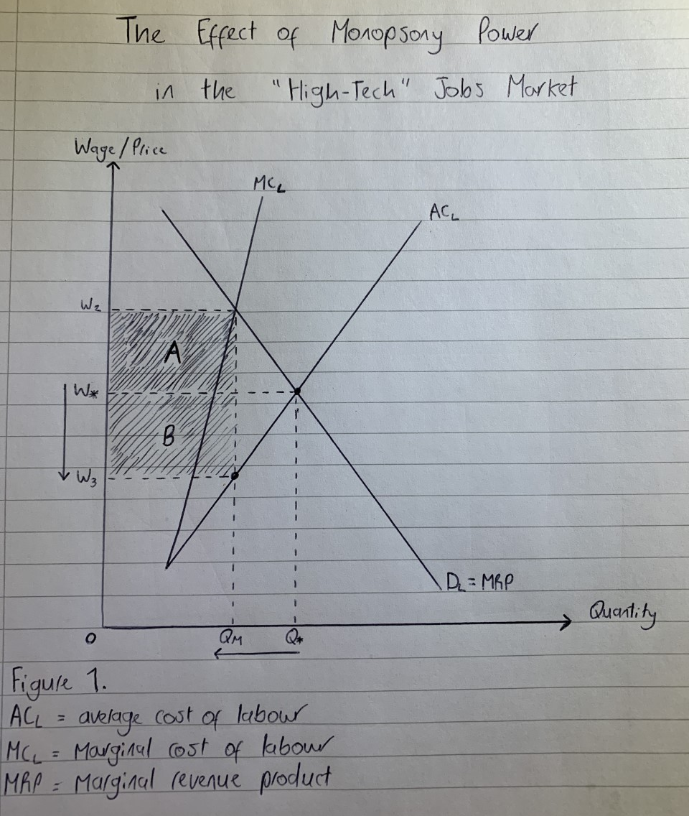
Appendices
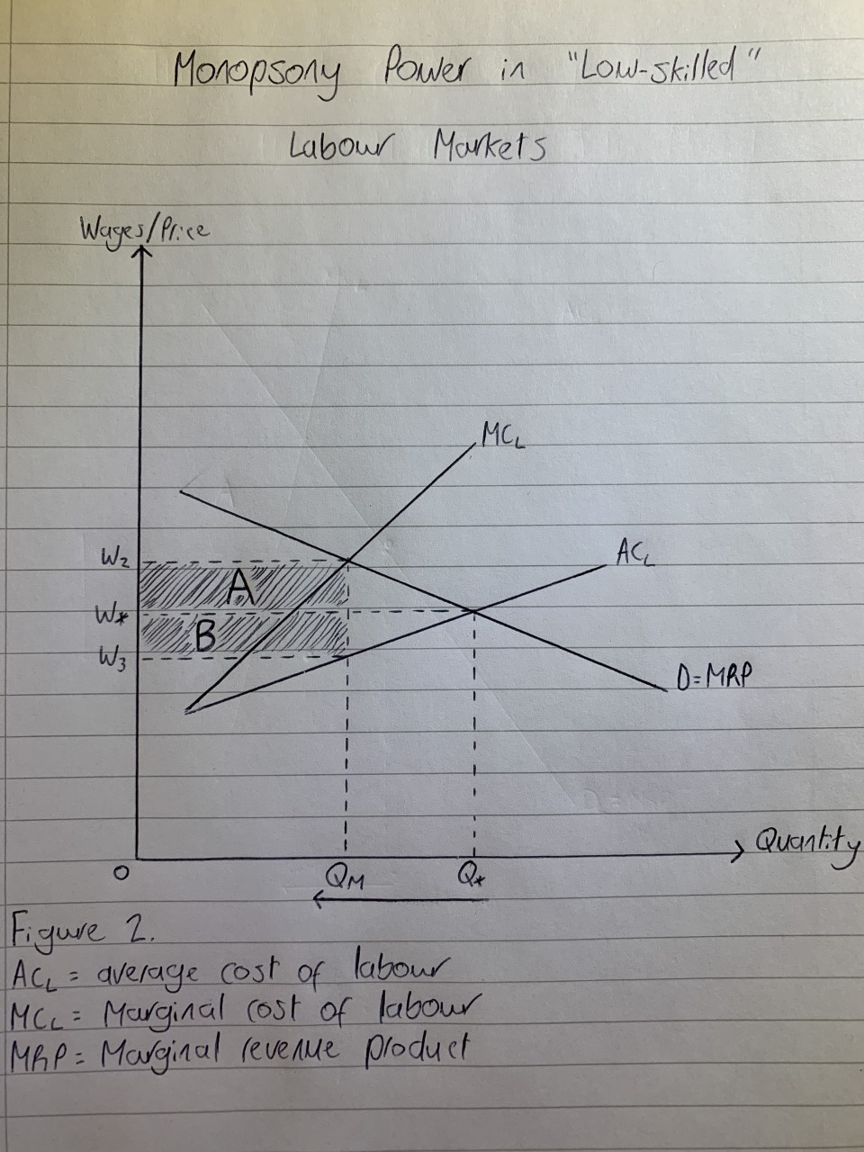

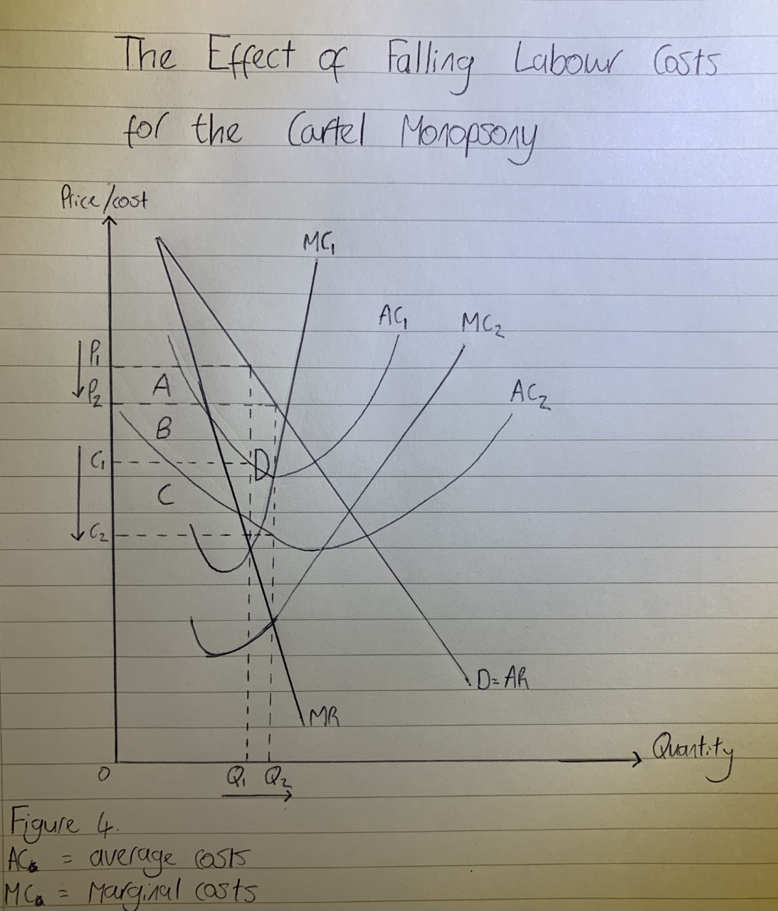


Bibliography
Bichhieri, C. and Lev-On, A. (2007). ‘Computer-mediate communication and co-operation in social dilemmas: An experimental analysis’, Politics, Philosophy, & Economics, 6 (2), pp.139-168.
Feinberg, R. (2016). ‘Cartel Stability: Determinants and International Evidence’, Review of Industrial Organisation, 48 (4), pp. 433-448. https://link.springer.com/content/pdf/10.1007/s11151-016-9503-6.pdf
Klein, G. (2011) ‘Cartel destabilization and leniency programs: Empirical evidence’, ZEW – Centre for European Economic Research Discussion Paper, 10(107).
Kleiner, M. and Won Park, K (2010). ‘Battles Among Licensed Occupations: Analyzing Government Regulations on Labor Market Outcomes for Dentists and Hygienists’, NBER Working Paper No. 16560
Manning, A. (2011). ‘Imperfect competition in the Labor Market’, Handbook of Labor Economics, 4 (b), pp. 973-1041.
Manning, A. (2020). ‘Why we need to do something about the monopsony power of employers’, LSE US Centre, September 5 [online]. Available at: https://blogs.lse.ac.uk/usappblog/2020/09/05/why-we-need-to-do-something-about-the-monopsony-power-of-employers/ (Accessed 29/04/21).
Miettinen, T. and Suetens, S. (2008). ‘Communication and Guilt in a Prisoner’s Dilemma’, The Journal of Conflict Resolution, 52 (6), pp. 945-960.
Office of Fair Trading (2013). ‘Applications for leniency and no-action in cartel cases’.
Von Auer, L. and Pham, T. (2021). ‘Optimal destabilization of cartels’, Journal of Regulatory Economics, 59 (1), pp. 175-192.
Warrington, G. and Snape, R. (2021). ‘Cartels 20201 / United Kingdom’, Global Legal Insights [online]. Available at: https://www.globallegalinsights.com/practice-areas/cartels-laws-and-regulations/united-kingdom (Accessed 01/05/21).

1114l

Management Studies Tripos

CORE MODULE
COURSEWORK

MS3

Economics of Firms and Markets

Course Leader: Dr. Frederic Schneider

Hand-in date:
03/05/21

1000
(1000)

I confirm that this piece of work is my own unaided effort and conforms with the Judge Business School guidelines on Plagiarism
(Do NOT sign)

Introduction
Market concentration is the relationship between a group of firms’ size and its collective market share (The Economic Times, 2021). The market concentration of the scientific publication industry has increased significantly since the digital revolution; between the 1990s and 2013 the five-firm concentration ratio increased from 15% to 51% (Larivière et al., 2015). This essay will explore the factors driving this change, before recommending policy interventions based on the market structure’s welfare implications.
Increasing Market Concentration
I propose that the correlation between digitalisation and concentration in this industry does equal causation, because digitalisation has allocated two roles to large publishers.
First, digitalisation has fuelled industry network effects. These exist where the value of a good increases with its consumption quantity, with this relationship becoming exponential beyond a critical mass of consumption. For customers, it is beneficial to purchase from publishers providing a greater breadth and depth of scientific journals. For authors, it is more attractive to have an article published by a publisher serving many customers, because they will receive greater exposure thus citations. Extending this, Larivière et al. (2015) argue that large publishers have the “symbolic function of allocating academic capital” to authors. Large publishers harness these dynamics by acting as platforms to bring together many authors and readers. Figure 1 shows how these network effects increase the minimum efficient scale (MES) of production (MS3, Week 6) from 25,000 to 50,000 units of production. Baumol (1983) explains that this larger MES will lead to a more concentrated industry structure, and will act as a barrier to entry because a larger market share is required to make profits. Referencing Figure 1, we might expect the number of firms in this market to fall from four to two.
Second, digitalisation has transformed scientific journals into information goods. Varian (1998) states that information goods have high returns to scale, thanks to their high fixed costs and negligible marginal costs. Digitalisation has removed the need to print and distribute journals, dramatically reducing marginal costs thus enlarging the economies of scale described above. Building on this, Varian (1998) suggests Malthus’ and Gresham’s law of information, which posit that (a) the supply of information grows faster than demand and (b) bad information crowds out good information. The combination of these trends may create a second rationale for large publishers: quality signalling to consumers. Scientific journals are experience goods, meaning consumers only know their value after consumption. Large publishers may represent a more trustworthy signal of a journal’s quality, reducing the market’s information asymmetry.
Preserving and Leveraging Market Power
The dominant publishers have sustained their market power through aggressive inorganic growth. To illustrate, Wiley-Blackwell acquired 39 journals per year in 2001-2004 (Larivière et al.,2015)
Another factor sustaining publishers’ market power is the Ingelfinger rule, which prohibits authors submitting their articles to multiple journals (Marshall, 1998). This gives each journal a monopoly over its published articles. This is important as each article is a unique good for which there is no perfect substitute. Further, these goods are excludable, meaning they cannot be consumed without payment. Knowing this, publishers can exploit consumers by creating large bundles that mix journals required by the consumer with unrequired journals. The law of large numbers means the predictive value of bundling allows greater profits (Bakos, 1999). Normally these gains are outweighed by the marginal costs of producing extra goods for the bundle (ibid), but digitalisation has eliminated the marginal costs of scientific journals.
The market power of oligopolist publishers has allowed them to increase these bundle prices, thus their abnormal profits (Area [A+B], Figure 2), at the expense of consumer surplus. These long-run profits are protected by the industry’s barriers to entry. Figure 2 shows the under-consumption of scientific journals relative to the competitive equilibrium, by Q*– Q⁰. This analysis is supported by the University of Konstanz’s decision to cancel its subscription with Elsevier (Larivière et al., 2015), with other institutions expressing similar sentiment. This leads to a deadweight welfare loss of Area C, because there is unproduced output for which the marginal benefits would exceed the marginal costs.
Policy Recommendations
This deadweight welfare loss justifies policy intervention. Further, the size of the deadweight welfare loss could be even greater than modelled because of the role scientific journals play in facilitating education, a good that is under-consumed even at the competitive equilibrium due to its positive consumption externalities (McMahon, 1987).
First, removing the industry’s barriers to entry and exit would be welfare-enhancing because incumbents’ abnormal profits will incentivise entrants, who will erode these profits. Therefore publishers will be incentivised to offer lower prices, moving toward the competitive equilibrium (Baumol, 1983). In this scenario, increasing market contestability could be difficult given the somewhat intangible nature of the barriers to entry. One way to address journals’ network and reputation effects is strengthening scientific societies, perhaps by increasing funding, whether directly from government or through tax incentives for private donors. These institutions can then allocate academic capital to researchers and signal quality to customers, thereby reducing the industry’s reliance on commercial publishers for these roles. This analysis is supported by Larivière et al. (2015), who linked the size of physics’ scientific societies to the relative lack of large commercial publishers in the discipline.
Whilst direct regulation could restrict future acquisitions or control prices, the second key focus of policymakers should be the Ingelfinger rule. This essay has focused on the oligopoly power of large publishers; however, they also have oligopsony power over authors. Conceptualising large publishers as platforms with two-way market power, competition ensues through “multihoming” when authors and education institutions have choice between platforms. Here, regulators foster competition by minimising the multihoming costs of switching between platforms (MS3, Week 6). Ingelfinger’s rule is a multi-homing cost as it forces authors to commit their good to one publisher, and from the consumer’s perspective it results in each platform offering uniquely differentiated content. Regulators should explore how the tension between Ingelfinger’s rule (and associated copyright rules) and multihoming costs might be resolved, to increase competition.

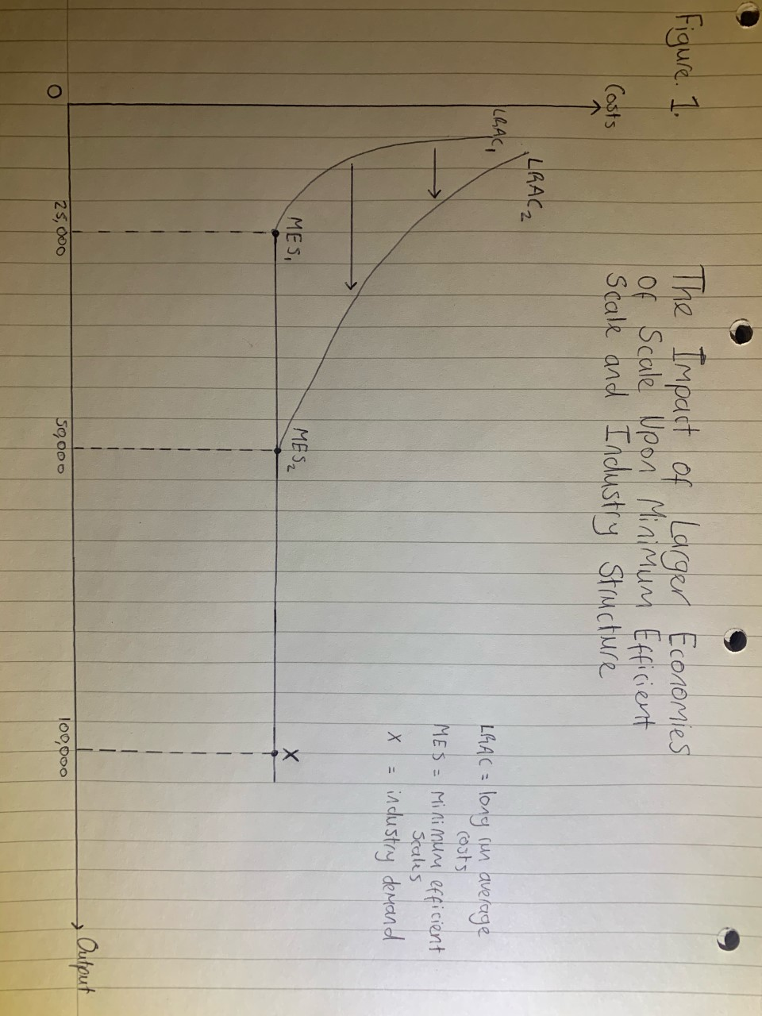
Appendices

Bibliography
Bakos, Y. and Brynjolfsson, E. (1999). ‘Bundling Information Goods: Pricing, Profits and Efficiency’, Management Science, 45 (12), pp. 1613-1630.
Baumol, W., Willig, R. and Panzar, J. (1983). ‘Contestable Markets: An Uprising in the Theory of Industry’, American Economic Review, 73 (3), pp. 491-496
Larivière, V., Haustein, S. and Mongeon, P. (2015). ‘The Oligopoly of Academic Publishers in the Digital Era’, PLoS ONE, 10 (6).
Marshall, E. (1998). ‘Franz Ingelfinger’s Legacy Shaped Biology Publishing’, Science, 282 (5390), pp. 861.
McMahon, W. (1987). ‘Externalities in Education’, Economics of Education: Research and Studies, pp. 133-137.
Schneider, F. (2020). The Online Economy, lecture handout, Economics of Firms and Markets MS3, University of Cambridge.
The Economic Times (2021). Definition of ‘Market Concentration’. Available at: https://economictimes.indiatimes.com/definition/market-concentration (Accessed: 02/05/21).
Varian, H. (1998). Markets for Information Goods. Available at: http://citeseerx.ist.psu.edu/viewdoc/download?doi=10.1.1.66.1159&rep=rep1&type=pdf

